VIP PROJECT: CREATING ACCESSIBLE MATHEMATICS AND STATISTICS RESOURCES COURSE CHECKER PROJECT

This is the edited version of this document. Edited by Madeline Koenig in April 2026. The original version, written by Anja Colombi, can be viewed at the end of this edited version.

STARMAST Course Checker Program Handover Document:
School of Mathematics and Statistics
Anja Colombi (ac457@st-andrews.ac.uk), Madeline Koenig (mak34@st-andrews.ac.uk)
Last Updated: May 2026
Table of Contents
Project brief 3
Problem Statement 3
Solution 3
Scope of work currently completed 5
Dataset structure 5
Future directions and outstanding tasks 5
Known issues 5

Project brief
This handover document will breakdown down the problem, solution, and benefits of the navigation page to allow students and teachers globally to access materials that align to their course requirements in a simplified way.

Problem Statement
Currently, STARMAST resources can be accessed via the website’s search engine, index or home page, making it challenging for users to identify materials that align with their course requirements and thus limiting ease of use and global adoption or the website.

Solution and Benefits
The project aims to produce a new interactive navigation system, allowing to find relevant STARMAST resources based on the course they are studying through user selection of country, exam board, course, content name, and guide title.
This new method of content management would allow for efficient access to relevant material as users will be able to quickly find guides that match their syllabus and clearer labelling will help students and teachers have clarity as to how the content STARMAST has fits within their learning pathway. Furthermore, this would allow for greater ease of global use with materials becoming more universally applicable and easier to adopt across diverse teaching contexts and school systems. There is also the potential for this to benefit the STARMAST team, with callouts within the CSV file to see where there are potential topic gaps. This will assist in prioritising topics for guide and factsheet development.

Scope of work currently completed

Dataset structure
The csv file to evolve the with headings {Country, Exam board, Course, Content Name, Starmast link, Guide title}:
- Country: Country of syllabus
- Exam board: Awarding body (for example: AQA)
- Course: To limit curricula (for example: A-level Mathematics)
- Topic: specific units offered within the course
- Starmast Link: The link to the STARMAST guide following the example format ./studyguides/introtoprobability.qmd
- Guide title: The official title of the STARMAST resource linked

File location
The current Excel and CSV file is under the name, “finalised_csv_content_management_final.csv”. Please speak to STARMAST Coordinator, Thomas Coleman (tdhc@st-andrews.ac.uk), to receive access to the file.

How to operate
Once the site is opened the user can select between buttons of each country. Once a button is selected it will be highlighted in official STARMAST blue and the next row of buttons becomes visible. Laying out the possible awarding bodies to choose from that country. This selection process is done repeatedly until a guide is pressed. This guide button is internally linked to the correct STARMAST guide, factsheet, or app. The user will be taken to the specific link to read the resource that they have clicked on.

Future directions and outstanding tasks
Recommendations of where to go with the current standing of the current project:
- Extend to further countries, exam boards, and courses specifically adding courses specific to the University of St Andrews.
- Continuing to update courses already mapped with new guides.
- Allowing personalised navigation or saved pathways so users can save their country/exam board/course preferences without having to re-select when revisiting the site.
- Enhance accessibility by allowing for full keyboard navigation.
- Incorporate advancements made this system such as:
  - Allow for multi-language support for the navigation system.
  - Using analytics to track most selected countries, most accessed courses, and thus most visited guides from the system – valuable for prioritising future guide and content creation.

Known issues/limitations
Most limitations stem on the navigation system’s dependence on the structure and consistency of the content management CSV file. See the following for specifics:
- There are no error tolerances so small inconsistencies in the CSV will break the code.
- Each new guide will manually have to be updated into each of the curricula.
- If a filename is changed internally, the link in the CSV file will break.

Contact details
Please reach out to Madeline Koenig (mak34@st-andrews.ac.uk) if there are any questions regarding this project or information in this document.

VIP PROJECT: CREATING ACCESSIBLE MATHEMATICS AND STATISTICS RESOURCES COURSE CHECKER PROJECT

Original Document
STARMAST Course Checker Program Handover Document:
School of Mathematics and Statistics
Anja Colombi (ac457@st-andrews.ac.uk)
Martinmas Semester: December 2025

Table of Contents
Project brief 3
Problem Statement 3
Solution 3
Scope of work currently completed 5
Dataset structure 5
Future directions and outstanding tasks 5
Known issues 5

Project brief
This handover document will breakdown down the problem, solution, and benefits of the navigation page to allow students and teachers globally to access materials that align to their course requirements in a simplified way.

Problem Statement
Currently, STARMAST resources can be accessed via the website’s search engine, index or home page, making it challenging for users to identify materials that align with their course requirements and thus limiting ease of use and global adoption or the website.

Solution and Benefits
The project aims to produce a new interactive navigation system, allowing to find relevant STARMAST resources by based on the course they are studying through user selection of country, exam board, course, and topic.
This new method of content management would allow for efficient access to relevant material as
users will be able to quickly find guides that match their syllabus and clearer labelling will help
students and teachers have clarity as to how the content STARMAST has fits within their learning
pathway. Furthermore, this would allow for greater ease of global use with materials becoming
more universally applicable and easier to adopt across diverse teaching contexts and school systems.
There is also the potential for this to benefit the STARMAST team, with the standardised
categorisation making it easier to see where topic gaps lie. This will assist in prioritising topics for
guide and factsheet development.

Scope of work currently completed

Dataset structure
The csv file to evolve the with headings {Country, Exam board, Course, Content Name, Starmast link, Guide title}:
- Country: Country of syllabus
- Exam board: Awarding body (for example: AQA)
- Course: To limit curricula (for example: A-level Mathematics)
- Topic: List of topics covered by the course
- Link: To list STARMAST courses related to the topic using filename from “starmast-master” folder

File location
The current Excel and CSV file is under the name, “finalised_csv_content_management_final.csv”. Please speak to STARMAST Coordinator, Thomas Coleman (tdhc@st-andrews.ac.uk), to receive access to the file.

Webpage structure and logic
The following figure highlights the planned logic for this new navigation page:
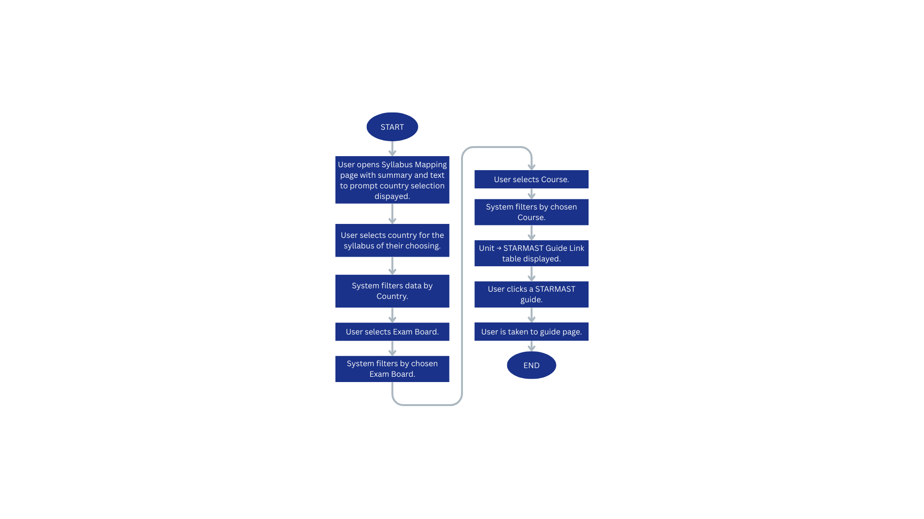
Figure 1: Flowchart highlighting logic for the syllabus mapping navigation page.

Future directions and outstanding tasks
Recommendations of where to go with the current standing of the current project:
- Extend to further countries, exam boards, and courses specifically adding courses specific to the University of St Andrews.
- Continuing to update courses already mapped with new guides.
- Allowing personalised navigation or saved pathways so users can save their country/exam board/course preferences without having to re-select when revisiting the site.
- Enhance accessibility by allowing for full keyboard navigation.
- Incorporate advancements made this system such as:
- Allow for multi-language support for the navigation system.
- Using analytics to track most selected countries, most accessed courses, and thus most visited guides from the system – valuable for prioritising future guide and content creation.

Known issues/limitations
Most limitations stem on the navigation system’s dependence on the structure and consistency of the content management CSV file. See the following for specifics:
- The mapping has been arranged using the file directory so if file names are changes the csv
will need to be updated.
- Missing guides for certain units means that units won’t show on the directory (for example:
Australia -> QCAA -> Specialist Mathematics -> Unit 4) does not show as there are no
relevant guides for this unit).
- As STARMAST is upscaled and the CSV becomes bigger the performance of the JavaScipt may
degrade, therefore optimisation may be required in the future.
- There are no error tolerances so small inconsistencies in the CSV will break the code.

Contact details
Please reach out to Anja Colombi (ac457@st-andrews.ac.uk) if there are any questions regarding this project or information in this document.

